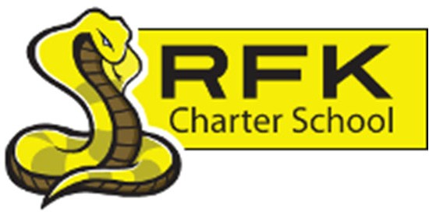

4300 Blake Rd. SW Albuquerque, NM 87121

PHONE: 505‐243‐1118 FAX: 505‐242‐7444

Mission

RFK Charter School prepares, motivates, and supports students to achieve their college and career goals in partnership with their families and the community.

**Governance Council Meeting Minutes Thursday, December 15, 2022**

**4:30 p.m.**

All council members:

# Roll Call:

Mark Walch

Lawrence Barela

Sylvia McCleary

April Gallegos

Michele Coleman

Trey Hammond

Denise Parras

**Zoom:**

None

**Absent (excused):**

Carlos Caballeros

Angel Garcia

**Quorum:** Yes

# Staff:

Robert Baade

Irene Sanchez

Shawn Morris

# Linda Ortega

# Guests:

Carlos Caballeros

# Approval of Agenda:

# Sylvia McCleary makes a motion to approve the December 15, 2022, Meeting Agenda. Lawrence Barela seconded the motion. All in favor. Agenda accepted and submitted.

# Approval of meeting minutes:

Lawrence Barela makes a motion to accept the November 17, 2022, meeting minutes with a correction to GC Board member’s name. Sylvia McCleary seconded the motion. All in favor. Minutes accepted and submitted.

# Public Comment:

# Bilingual Data

# Linda Ortega the Bilingual Coordinator reported on RFK’s Instructional Response LCF Bilingual Evaluation Report for 2022.

# Middle School Update / High School Update:

# HS Principal, Shawn Morris reported for both MS and HS.

# MS has 79 students enrolled. High School has 291. With a total count of 370 students. (40 Day Count -FY23)

# Chronic Absence is what RFK is seeing.

# Shawn reflected on RFK’s Fall Site Visits. All areas checked out green. Which is defined by, “Meets”.

# Finance Committee Report:

# Lawrence Barela makes a motion to approve the Finance Report for November 2022. Lawrence Barela seconded the motion. All in favor. Motion passes and carries.

# Cash Disbursements:

# Lawrence Barela made a motion to approve November 2022 Cash disbursements totaling, $430,373.58 Sylvia McCleary seconded the motion. All in favor. Motion passes and carries.

# BARS: No bars to report.

# Equity council:

# Director, Robert Baade has been working with MS Principal, Aaron Arellano in developing an Equity Council. With plans to be up and running by early Spring of 2023.

# Executive Director’s Report:

# Director, Robert Baade reported on how proud he has been on Career Pathways beginning next semester. YCC starts in March, Employing 20 students until Fall Harvest. The rest of his report was touched a bit throughout the meeting.

# Housekeeping:

# GC members who have not finished their training are encouraged to get this done soon. Irene needs shirt sizes and Bios for the website.

# Adjourn:

# Lawrence Barela makes a motion to adjourn the meeting.

# Mark Walch adjourns the meeting at 6:36 p.m.

# Next meeting:

# January 19, 2023

# Minutes by:

# April Gallegos